Trading 2016_10_10

That was a long vacation.

Few thoughts:

1. hold good stocks with good fundamentals. A few of these would do
2. Going in and out doesn't make money. Holding onto the position does.
3. Trading around the position is important. But not as important as picking a good stock and hold.
4. Recently, strategic holding in USDJPY has paid off with no overtrading.
5. Make sure your portfolio also has other exposures including commodities like gold and oil. This helps you gain a general view of world markets.
6. US equities.

Money transfer:

Vacation spots:

Taiwan:

People are more friendly in the south. Put more effort into image building.

Visit Taichung and Kaohsiung next time.

目前在台湾的住宿费还是太贵, 需要把它降到一个合理的范围,一天300最多了.

XU opened up and small sized selling orders drove out most of the short term traders.

Markets are weak. RMB depreciation is taking its toll on the index.

Cash is still living the country. When you bring cash out, deposit at city bank, citibank will need to exchange rmb for USD which will reduce china's reserves.

**Tuesday, October 11, 2016**

Yesterday the trend is very clear. With the cooling down of property market, cash will make its way into smaller stocks. Small stocks were up 3% yesterday. Signifying its strength for the days to come. Right now it is a relatively attractive level to start buying some small stocks.

Yesterday main index was dragged down by the property sector, which is adversely impacted by the regulations that came out during the holidays. Smaller stocks did not have anything holding it back, therefore explaining its strong performance.

In terms of shorting RMB, I pay benchmark + 5% (6.8%) to short. I am earning about 3% interest rate onshore. Unless currency depreciates more than 4% I am not making money on this trade.

In terms of account balances, I am not making

@1146 Build some position in 700 and HSCEI. HK property sector is facing some pressure as Anhui Conch is the most shorted stock. Given China's current RMB situation, good stocks in HK will experience inflow. The banking sector due to real estate exposure will likely be weak.

Wednesday, October 12, 2016

Down quite a bit on the H share position.

Some short covering was seen in the morning.

The selling pressure is pretty big.

@927 Everything is selling off.

@930 One can sense that offshore is very nervous.

First reason is US weakness, they sense rate hike is coming, people are aggressively cutting risk. A is outperforming.

@958 Yesterday bought too fast. Don't buy consecutively. H share has more real moves than A, A often has rebounds (especially on Tuesdays) but H doesn't have this. Hold the H position as exposure to US equities, hold it for the long term.

@1042 Market hasn't reached closeY. With the previous 2 days performance today's afternoon does not warrant any buying. The portfolio recently is way underperforming the index. Mostly due to H share taking a hit with the US,

@1054 Can trade on morning close/pm close. When morning is bullish, release some risk in early PM (especially Mondays / weekdays pmFirst10<0). When morning is bearish, start buying some in early afternoon.

HK will take any opportunity to take profits. If you look at long run H share performance, it still hasn't covered the 2007 highs. Most of the cheap money has gone into housing. H share is how investors short China property sector, it is where foreigners can trade, so be extra careful about long this index. The loss recently is a testament of that shorting, which still continues now.

@1331 Things don't look that great. One mistake is adding position on H too quickly yesterday. Position accumulation needs to be slower. H down over 4% in less than 2 days.

@1551 A day where H share did not even have a chance to breathe. Sell-offs in all property related sector, and sparking off fears of the bad loans in banks. Property+banks that's most of the index. Brokerages are getting sold off because H doesn't look attractive to invest anymore.

Stocks keep getting affected by US's rates. Asians like to put money in properties so stocks never received any liquidity. Property market in HK is achieving new highs, where stocks aren't doing anything. Stocks never achieved the highs of 2007, the H companies have not been benefiting from the new economy.

@2249

Thursday, October 13, 2016

Yesterday US ended the session mixed. Asia opens weak, opening a bit higher and quickly sold off. Shcomp closed at 80%, closing in high percentile three days in a row, H continues to underperform. Long USD are the only profitable position. Liquidation of HHI continues.

Stop adding to H for now. You added too quickly two days ago and now there seem to be big algos selling, including a lot of foreign funds -> cannot go against this trend. It is interesting that people are not buying any H. But looking at the long term, H.S.I and hscei haven't even broken their 2007 highs, so these are not really good to invest for the long term. Lots of losses are cut are here, everything is getting sold. It is currently a big target for shorts and shorts are accumulating heavily in H.

@1019

H sells off another 1.5%, A remains flat. The H is really breaking. Down 5% since market reopened, my position on it is bleeding heavily. It doesn't even rebound or offer any opportunity for day trading. This might be the reason people prefer property than stocks. Stocks don't even offer attractive opportunities in the long run. With low rates and after 2008 when property doubles, market doesn't even move, comparing this with the SPX, HSCEI is really not a good target. Market completely capitulates as H investors.

To trade H you need spreads, cannot long the index because index doesn't go up in the long run.

You need some gamma on this. Gamma and spreads are the way to trade H. A lot of short gamma is run into on the downside, this 5% selloff is pretty quick.

1. Shorts
2. Spreads
3. Gamma

Currency it was much easier, long USDJPY was simple. Oil bottom is pretty simple. The asset trades correctly. Even in the long term H way underperforms world indices.

Europe is at historical highs.

Going forward, you need to be careful about purely doing delta in this market. This is a big lesson. With no shorts, no gamma, no spreads, the position is just very exposed, if direction is called wrong then it's a huge loss. Now the position is only about 300k HKD, but its already caused a loss of 10k, which is already 3%. The position needs to climb back 3.3% for me to break even. That is difficult.

@1046 HK is retreating because it is influenced by US, which

Analysis of the long term: HK underperforms most world markets. It is made up of Chinese stocks which foreigners don't like, especially banks and property. It failed to rally even with interest rate at 0.

Now it is basically china investors vs. world short sellers.

@1102

Several things: Keep position light.

Do strategic trading only. Bear market mode. Pick positions of strategic advantage and keep position light at other times.

HK – hedge delta, trade gamma and vol, and spreads. Use call/put spreads.

This take-on of naked delta with no other hedges is pretty bad.

Holding indices is a waste of time. You have to adjust position.

The key is hold little position and add very gradually and only add in strategically important places.

On 9/9 the addition was too quick. Long some gamma on the weekend and hedge your delta through some put spreads. The way HK works is it is better for shorting.

The market is not good for long term holding and you are holding whole position long without any short position, this is bad. You need put spreads, you need to short certain sectors. Keep this in mind. Fully diversify.

Now there are currencies. It would be better to have commodities (metals and oil), bonds, and derivatives, not just delta-1 futures. The market moves too fast in HK, optionality is more valuable than Chinese options, Chinese indices don't move.

So overall, hedge china exposures with futures and hedge HK exposures with options. Good that currently don't have too much position on.

@1457 Reducing equity exposure. H is firmly stuck after down 5%, this is a lesson going forward. You need to long gamma with any delta position, paying some theta is fine.

@1514

Examining the global situation, it is tough for cash holders.

这次是吃了H股的大亏了. 之前以为大陆的资金会南下香港, 为了保值, 是人民币的唯一去处.结果港股在节后被大幅度抛售, 一点都含糊, 损失惨重. 这么干太伤人气了. 人民币对外贬值, 对内没有投资渠道, 满地是钱但是没地方投资. 这是要把现金持有者给打死. 中国走出这种行情,肯定会有个反弹, H连个反弹都没有, 完全理性跟着估值走. 也就是Chanos说的.

Changing mode. Keep light positioning and stay away from equities.

Friday, October 14, 2016

Market is pricing in a little rise for HK and a fall in China.

Trading HK is not my expertise. Be careful of post-holiday moves, the same as you are careful of Mondays. This week, Market sold off very quickly on Tuesday AM, the first day after the holidays. This would set the tone for the week. It is the worst performing index this week.

Again, this is barely what your expertise lies.

The plan for the next while is to focus on an equities strategy based on the key shcomp stocks.

Market didn't reach closeY, cutting risk.

@2323 premium reached 40 bps after close,

Weekly Recap:

A50:

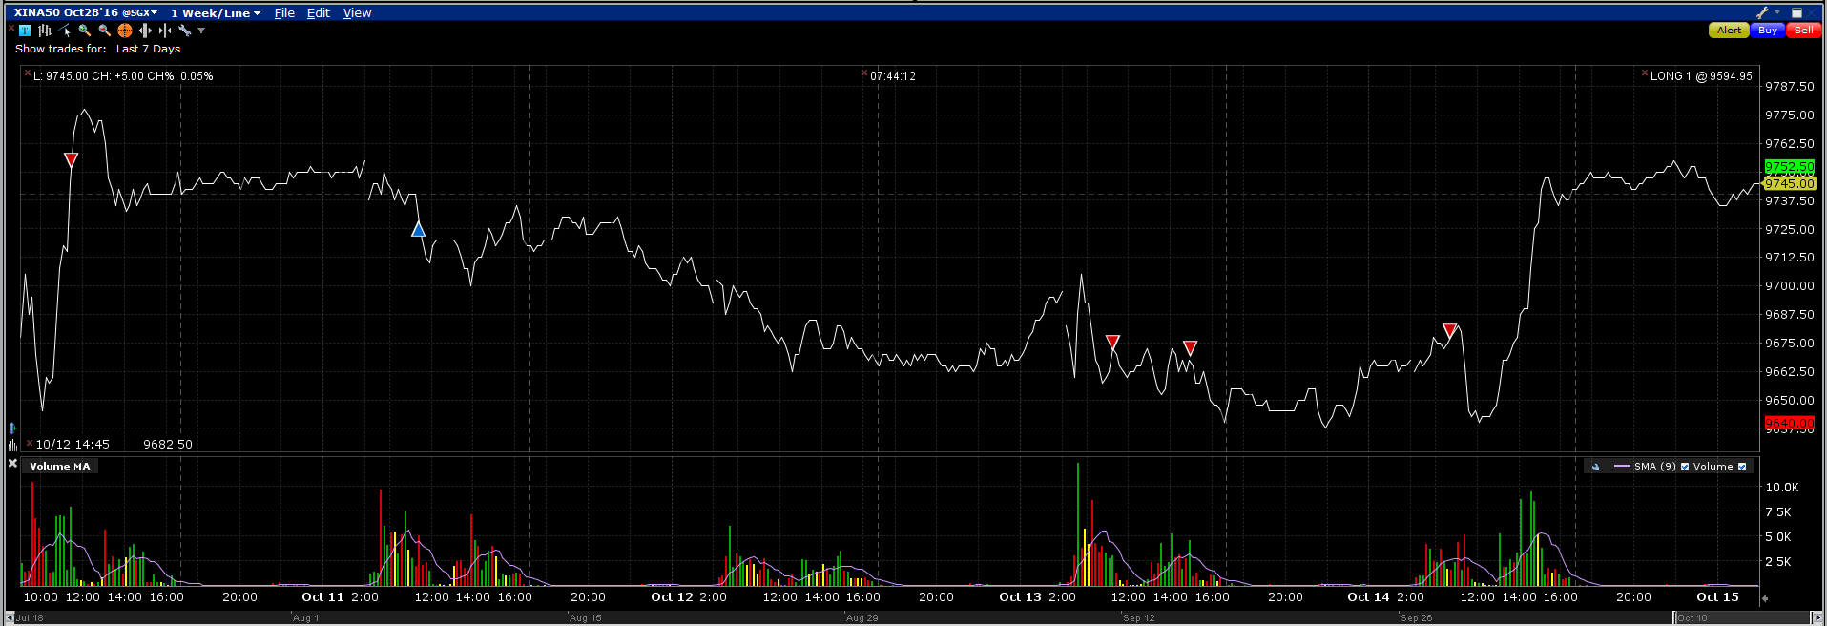

Monday had a greedy move up. Tuesday bought at AM close, which was ok, the rebound was powerless. Wednesday was weak. Thursday sold 2 lots. Friday morning sold another lot and rebounded in later afternoon.

Friday PM first10 was positive. I don't like too much risk on Fridays, especially when market in downtrend. Heavy lesson on Sep 9th.

HHI:

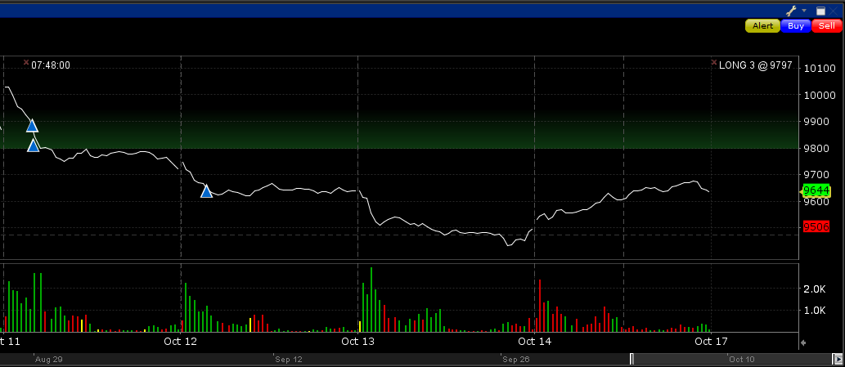

HK was off on Monday and on Tuesday it opened up and soon started a 3 days drop. I bought too early on Monday, not realizing it is the start of a down trend. I thought the market was still in an uptrend although I can't come up with any reasons for it. The market was going down without any rebound. I bought again on Wednesday morning without much justification. Over the Tues-Thurs period I dropped more than 3% on this position while the index lost more than 5%, way underperforming any other markets.

The issue with H and A are that investors don't like the constituents of the index so they systematically short it and it underperforms the other indices, especially US and Europe.

USDJPY

DollarYen position continues to strengthen. As market failed to break the 100 level, long position here has reaped some profits. This shows markets are short sighted and prices are affected by short term fluctuations (news etc) and does not focus on the long term. However, in the long run, fundamentals will catch up. Short term prediction is useless, while long term prediction might have some merit.

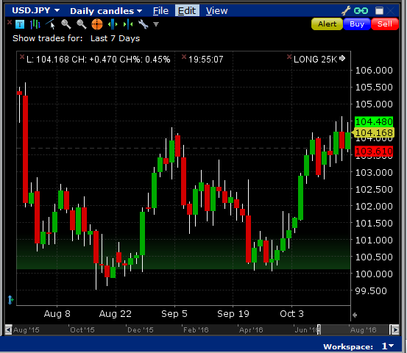

USDCNH:

